SNOW’S CONFESSIONS
雪的自白

By Li Li
Translated by Denis Mair

I

迁 鸟

飞过沙漠，冰川，飞过栅栏里的牲口……
落日把它们烧成枯瘦的鬼魂
它们在天上写着无人看懂的诗行
钢琴无法弹出它们翅膀的旋律
它们为翅膀飞翔！它们穿过暴风雪
返回新芽舞动婴儿手指的南方
一条千里长的线
等待最完美的点——子弹——从地面上升起

Bird of Passage

Flying over glacier and desert, flying over livestock in their corral
Sunset ignites them into gaunt ghosts
They write lines of poetry no one understands in the sky
Pianos cannot perform the melody of their wings
They fly just because they have wings
They pass through blizzards
Return to the south, where saplings wave infant hands
A thousand-mile line awaits the perfect point—a bullet—to rise
up from the ground

雪

一
不是柳絮，是安魂曲
它弹奏冬天。让白
穿行医院走廊，把“救命”
堵在一张干燥的嘴中

二
雪人。温柔的纯洁！
我把蜡烛插入它胸膛
一道伤口在深处闪现：激情
只是冰河里的漂木！

三
这雪必须铲除。脚打滑
车祸。最好远离此地
或相反：反抗。铲子下
耳语轰鸣：“请用更多的恨！”

四
我在街上行走。暴风雪
教会我生活：低头，沉默
当哈气从阴沟里冒起
天空用更大的静卡住我喉管

Snow

1
It is not willow floss, it is a requiem
Performing the winter. It sends whiteness pacing
Along hospital hallways, stops the cry “Help”
From escaping a desiccated mouth

2
Snowman. Personifier of purity
I stick a candle in its chest
A wound opens deep inside—passion
Will solidify like driftwood in a glacier!

3
This snow must be shoveled. Feet slide
Car crashes happen. Best to leave this place
Or do the opposite: resist. Under the shovel
A whisper rings in my ears: “Put more hate into it. ”

4
I walk down the street. A blizzard
Gives a lesson to live by: be silent, keep my head down
While steam puffs up from a sewer pipe
The heavens lock my throat with greater stillness

交 往
——给一个金发女郎

我走来。你握住我伸出的手
但交谈时别看我眼睛
那里是夜，暴力
那里是墙，堆积的尸骸

别在饭里到酱油！
我会皱眉，看见雪地里的屠杀
别问吃的是什么肉
微笑，是我不变的回答

别在我替你打伞时说“喜欢……”
我会盯视冒烟的车尾
把话留到床上，我
会让你听古战场的铁鼓

别先脱。我会慌乱
脱吧！如果你一定要向我——爱情
展示无法承受的伤口
我会惊叫：哦，大海！

别谈未来。谈现在：波浪
做鱼的技法。我会
闭眼，哼唱京剧里的
老生：“流水落花春去也”

别提你名字。安娜，玛丽
到我耳边，都变成
啊——嗷——哇——咿
无法理解，就像中文对你

你的名字很快被遗忘混淆
埃玛变成挨骂，安琪成变暗妓
但记忆——你吻过的手
会继续抱你，像你登过的长城

Having a Relationship with a Chinese Man
——for a young blonde lady

He walks up to you. You hold his extended hand
When conversing do not look into his eyes
There is night there, and violence
There is a wall, corpses in a heap

You share a meal. Watch out! Don’t pour soy sauce
Over your rice. He will see blood spattered in snow
Don’t ask what meat you are chewing
A smile will be his only answer

When his umbrella shields you, don’t say “I love you…”
He will stare at the exhaust pipes of cars
Save the “love” for in bed
You will hear drums from an ancient battleground

Don’t undress first. His limbs will lose composure
Well, strip then! If you insist on revealing
Your unbearable wound to him—love’s face
A cry will escape his lips: Ah, ocean!

Don’t talk of the future, talk of now: the waves
Or ways of cooking fish. He will liven up
Close his eyes, sing like a hero in Beijing opera
“Streams flow, flowers fall, spring has run its course!”

Don’t say your name. Anna, Marie
In his ears, these names become
Aww—Aarh—Whaah--Eeehh
Opaque syllables, like Chinese to you

Sounds of your name will get jumbled
Emma will become āi-mà [1]; Angel will become àn-jì [2]
But memory—the arm you showered with kisses
Will keep on embracing you, like the Great Wall you climbed

[1] Āi-mà means “suffer a tongue lashing” in Chinese.
[2] Àn-jì means “prostitute in disguise” in Chinese.

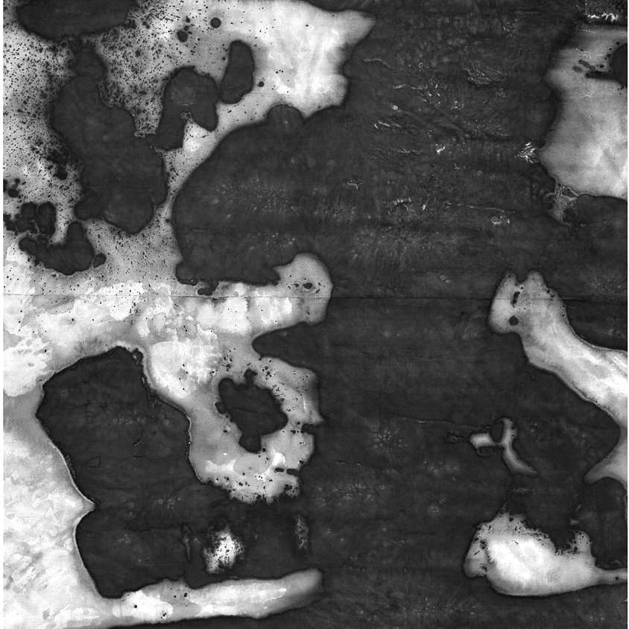

旅 行

比黎明醒得早，我，一列雾中
轰鸣的火车。变形的脸
晃摇，用街灯和夜作爱的激情
一道充血的目光打开空荡的车站

鸟声用死囚的母语在窗外涂写
“我想回家！”的啜泣
在钟盘的雪地里爬行。那里
记忆之狼正噬咬着一个迷途的孩子

Traveling

Awake before dawn—yes I, a train rumbles
In the mist. Smeared faces slide past me
By street lights and last night’s lovemaking
My blood-suffused gaze fathoms the empty station

Birdcalls in the native tongue of condemned prisoners
Scrawl their sounds at the window: “I want to go home!”
On the clock’s snowy face, wolf of memory crawling
Gnaws on the flesh of a child who lost his way

在克雷特岛

涛声递来枕边的呻吟
天越暗，这根倾斜的棕榈
就越像一根断折的柱子
我对脚下的废墟一无所知
但我不停地踩踏，快活，像腐尸上一条滚翻的蛹
我的目光从地窖里抽出
移向屋顶，飞入鄙视人类的苍穹
风吹来，把解开衣扣的我
吹成一只五月的蝴蝶
一切在飘！
我吐了口痰。哦，不留点东西
又怎能和时间的情人——废墟——融为一体？
波浪咆啸，冲撞。它们的蓝
碎成一扇扇门。它们的白
凝成交错的墙。一座阴森的迷宫！
“飞吧，伊加洛斯，家在远方！”
“飞吧，一生的囚徒！”
我回头，一条被压成胎儿形状的狗和公路飞来

On Crete

Moan of breakers reaches my pillow
Under darkening skies the tilted palm trees
Look more and more like broken pillars
I know nothing of the ruins under my feet
But I tramp about like a happy grub, wriggling on a corpse
My gaze pulls away from the cellar
Moves to the rooftops
Goes into the sky that disdains human beings
I open my shirt to freshening gusts of wind
That blow me into a spring butterfly
All is adrift. I hawk up some phlegm. If I leave nothing
How can I be one with the ruin—this paramour of time
Waves roar upon impact and break
Their blueness stands
Into doors and more doors. Their whiteness
Overlaps to make a wall
A forbidding labyrinth!
“Fly, Icarus! Your home is far away.”
“Fly, you lifetime prisoner!”
I turn my head: flight brings the roaring highway near
A run-over dog, in fetal curl, tugs it toward me

在埃及

帆收起尼罗河上的落日
“给我父亲一点小费吧！”他轻声说
四十岁的男人，看上去足有五十
他父亲，一个瘦老头
把着橹，静坐船尾
河水暗成他脸上的皱纹
我逃离的黄河艄公在天水间闪现

旅行在继续

颠簸的小路
我骑马进入法老黎明的墓穴
马蹄回荡拿破仑征服埃及的幸福
“看日出时的金字塔
比看日落时的好”
昂贵的私人导游说
突然，一个血红的球体， 一个
婴儿的脑袋
从深渊冒出。世界
被两个巨大三角形，两个高耸的乳房
挡住

旅行在继续

屏息走入。黑暗。呛人的汗味
无法读懂的文字在墙上呢喃
感到三千年
就是我此刻屏息的一瞬
感到黑暗
在用香油把我抹成铁色的面具
我突然大口喘气
我爬了出来
我爬了出来
我是一个复活的木乃伊。阳光多么美好！

旅行在继续

一个头顶箩筐的女人
她在移动。周围的沙漠
拖着废墟的村庄扩散
她在原地走动
琥珀里的虫子
她在我盯视时闪耀：一座狮身人面

旅行在继续

哦，需要对沙漠盯视多久
甜美的房间才会闪烁？
钢琴，书架才能从地底下升起？

烤焦的化石，一只蜴蜥的足迹
它们时而散成刺眼的阳光
时而聚成我移动的影子

影子是盲人的手
影子在摸，在读
但沙子的《奥义书》扩展成无限

这里没有东西腐烂，枯萎
这里没有东西生长
只有孤独
才能在这里找到幸福！

我听见脚步声
从远处的地平线那里到来，又像是从背后
我凝神，一阵干热的风
进入我鼻孔

单调的线条和色彩
它们重复自己的赤裸
它们省去了包装
它们省去了纽约的高楼
它们省去了罗马的教堂
它们省去了北京的宫殿
它们省去了巴黎的商场
它们省去了对春天的期待

我的脸裹着白布（只露出眼睛）
这是阅读而不受伤害的条件
（在纽约，我会被当作恐怖分子）
这里唯一的恐怖是阳光！

我读到法老用过的香水——一块小小的彩色玻璃
我读到香水的语言：
“抹把，让肉
闪耀成月光，笼罩两人的棺材

一只残破的铝制水壶
一根生锈的表带
一块代表墓碑的石头
一个死亡的天堂！

没人真正读懂我， 沙漠说
读懂了，就会留在我身边！

In Egypt

The Nile River sunset is rolled up in a sail
“Give my father a tip!” he says softly
This forty-year-old man, pushing sixty by his looks
His father, a gaunt codger
Mans the tiller, seated quiet in the stern
River’s surface dims to match his wrinkled face
Vision of the rivermen I fled from hovers over the water

My travels continue

Bumpy rutted road
I ride a horse into the pharoh’s graveyard at dawn
Hoofbeats tap out Napoleon’s happy advance to Egypt
“Viewing pyramids at sunrise is better
Than viewing them at sunset,”
says the overpriced guide
Suddenly, a blood-red ball,
An infant’s round head
Looms out of the abyss.
Great peaked shapes, two towering breasts
Pose an obstacle to the world

My travels continue

Hold my breath and go in. Darkness dank with sweat.
Mutter of unreadable words on the walls
Three thousand years feel like
The interval of my held breath

The darkness feels like
An appliqué mask of iron-colored unguent
Suddenly I am panting
I have clambered out
I have clambered out
I am a mummy reborn. Such beautiful sunlight!

My travels continue

A woman inches forward with a basket
Balanced on her head. The desert extends
In all directions, trailing ruins of villages
She is walking in place, an insect in amber
She radiates as I stare at her
Statuesque lion with human head

My travels continue

Ah, how long must I stare into the desert
Before an inviting home will shimmer there
And a piano with bookshelves will rise from the ground?

Sun-baked fossils, footprints of a lizard
Now they scatter in dazzling rays of light
Now they gather in my shifting shadow

My shadow is a blind man’s hand
My shadow feels its way, tries to read
But the Upanishads in sand expand without limit

There is nothing here to wither or decay
There is nothing here to grow
Only solitude and the nameless
Can find happiness here

I hear footsteps
From the far horizon, perhaps from close behind
I fix my gaze, breathe the dry hot wind
Deep into my nostrils

Monotonous lines and colors
They are repeating their own nakedness
They dispense with all packaging
They dispense with New York office towers
They dispense with cathedrals of Rome
They dispense with the palaces of Beijing
They dispense with the markets of Paris
They dispense with anticipation of spring

My face
Is wrapped in white cloth (with only eyes showing)
This is crucial to reading without being harmed
(In New York, I would be taken for a terrorist
Here, the only terror is sunlight!)

I read of perfume used by pharohs—chips of colored glass
I read the language of perfume:
“Rub this on: flesh will gleam like moonlight
Which falls upon a coffin for two.”

A crumpled aluminum canteen
A corroded watchband
A stone laid to mark a grave
A heaven for death!

No one reads my true message, says the desert
Whoever does will abide with me!

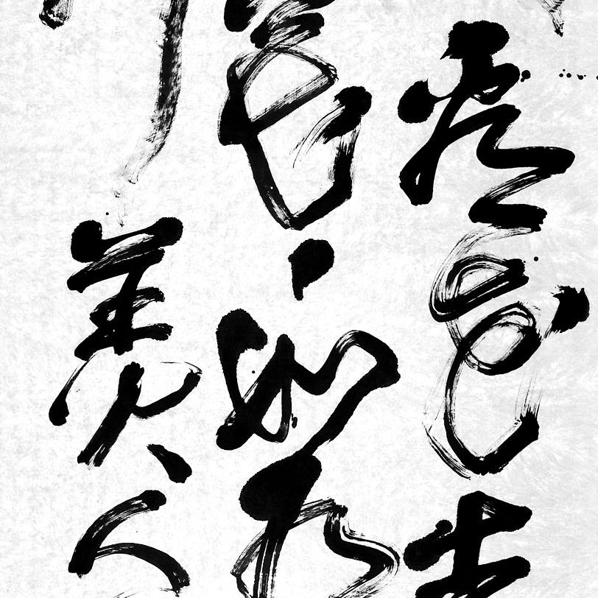

纽 约

石头的蜘蛛网，辉煌的几何图，帝国的心脏
我在那里走动，变成蚂蚁。一瓶可乐

把我领入地窖。垮掉一代的大师
在那里讲禅——他不再嚎叫

帝国脚下，沙漠繁殖着恨
直到深处的石油把飞机化为导弹

泪，从时代广场的广告涌出，涌向
滴血的十字——最精致的几何。爱，复活了

New York

Spider web of stone, glittering geometries, pulse of empire
Traversing its spaces, I become an ant. A bottle of cola

Brings me to a basement. The master of Beatdom
Speaks of meditation----he no longer howls

Under empire’s feet, roots of the desert proliferate
Till deep petroleum transforms an airplane to a missile

Tears seep from billboards on Times Square, trickle toward
a blood-dripping cross----what geometry could be more refined?
Here love is resurrected

瞬间的巴黎

大海——卢浮宫——让我们在咖啡里抛锚
但黄昏逼我们起程
赛纳河！十八世纪的桥。一个年轻女人
依偎着栏杆。宫殿，塔尖，晚霞
墨绿的梧桐树——整座巴黎
都围绕着她：一朵你眼里的玫瑰，一个我
心中的圣母——她突然
坠
落，像个包裹。圣母院的钟敲落天上的黑暗

Paris in an Instant

The oceanic Louvre—let us put down anchor in coffee
But dusk would have us set forth
The Seine! A seventeenth century bridge. A young woman
Leans at the railing. Palaces, spires, afterglow
Inky green plane trees—she is the centerpiece
Of this monumental city—a rose in your eyes
Holy mother in your heart—suddenly
Down
She plunges, like a parcel. Bells of Notre Dame
Toll down the darkness of heaven

Porto Banus

天鹅白的游艇依次停靠
个个含笑，个个矜持。一张皇家照片

这是现代宫殿。神圣的私人财产
“我们是世界公民，我们有白云的护照！”船说

海摇动着它们，像爱摇动着摇篮
海因这些金属的白云变得更蓝

一个光脚的乞丐出现。“我来这里
不是为见识，而是为了汲取仇恨的力量！”

Porto Banus

Swan-colored yachts line up at the dock
Each one smiling and proud, snapshot of a royal family

Modernity has its palaces. Sacred private property
“We are citizens of the world. We hold passports of white clouds,”

The ocean rocks them like love rocking a cradle
These white metal clouds make the ocean bluer

A beggar appears. Euuw, fly on a coffee cup
“I am not here for the sights, but to soak up fuel for hatred”

栖居地

废墟是最完美的房屋，没窗，没门
你可以从不同方向进入，像手
在灯关掉时
摸向另一个躯体，并被呢喃的口水搂住
一座积雪的废墟！
你走入。打颤
但死死咬住“里面真冷”的叹息
里，并不存在
一切是外，表层
深处是闭眼（如互相摩擦的念珠）
你闭眼。你离开的地方归来
火焰
一个男孩站在窗口叫喊。但喑哑
废墟上升，扩散，变成城堡
围住你来回搬家的脚步
直到你住脚
躺成门槛：“这里不再有地址和人名！”

Hermitage

Ruins make a perfect house: no windows and no doors
You can enter from any direction, like hands
When lights are out
Groping toward another’s body, being held close
By murmuring saliva
Pile of ruins housing snowdrifts!
You walk in, shivering
But swallow the sigh—“It’s cold inside.”
Inside does not exist. All is outside, a surface layer
Depth is in closed eyes (like rosary beads rubbed together)
Your eyes close. The place you left returns
Flames
A child stands at a window shouting, his hoarse voice unheard
The ruins rise high and widen, become a fortress
Which hems in your halting steps, until you stand still
Then lay down—and proneness turns you to a threshold
“This is no place for names or addresses!”

1989年1月的卡夫卡

人流的城堡。他站在
车站的出口：一双羞涩的大眼

“我叫卡夫卡” 他
上来帮我提包。”我愿做你的导游！”

我们对视。
我跟着他。跟，就是读

到处是没人要的煤——积雪
有轨电车拖着忧伤在爬

朝左，向右，直走
我跟着他。我是他影子

“那金顶建筑是歌剧院”
他微微一笑，“但关着！”

旧城。高大的铜像
“这是Jan Hus，500年前……”

尼康在我胸前晃动
卡夫卡眯眼打量

“这东西……要多少钱？”
“不到九百美元”

卡夫卡眼放星光
风景旋转成轮盘。我在哪儿？

“李，是否想喝杯咖啡？”
卡夫卡看到了他读者的晕眩

说到咖啡，咖啡馆
就出现在眼前：巴洛克风格。我们走入

“把大衣存了，还有
那相机，带着……多重！”

我们坐下，布拉格的咖啡
打开东西方的对话

“卡夫卡先生，你到过北京吗？”
“没有，但我想北京一定是座更大的城堡……”

沉默。咖啡
在品尝两个陌生人兴奋的奇遇

“对不起，请稍等一下”
卡夫卡神色严峻，“我父亲

在街对面等我” 卡夫卡
就这样走了。卡夫卡就这样一去不回！

查尔斯桥上风景如绣
我站着盯看桥下的漩涡

一只海鸥在我头上出现，盘旋
“我是卡夫卡。我拿走了

让你变成甲虫的相机
我让你提前走出你想逗留的城堡！”

Kafka in January 1989

Walled city streaming with people. He stands
At the station exit, a pair of bashful eyes

“My name is Kafka” He steps up to help with my bag:
“I am willing to be your guide!”

We look into each others eyes.
I follow him. This kind of following is reading

Coal no one wants is strewn about---snow in drifts
A trolley crawls along dragging dejection

Leftward, rightward, straight ahead
I follow him. I am his shadow

“That metal-domed building is the opera house,”
Says Kafka with a smile, “But it is closed.”

The old city. An imposing bronze stature
“That is Jan Hus…..500 years ago…”

A Nikon is slung at my chest,
Kafka narrows his eyes to look

“This thing…what does it cost?”
“Umm…not quite 900 dollars”

Kafka’s eyes shoot stars
Scenery spins a roulette wheel around him. Where am I?

“Sir, would you care for some coffee?”
Kafka sees the giddiness of his counterpart----the reader

At the mention of coffee, before us appears
A coffee shop, baroque in style. We walk in

“Check your coat, this place is heated
And your camera…is too heavy to carry!”

We sit down. The Prague-style coffee
Initiates an East-West dialogue

“May I ask, have you been to Beijing?”
“No, but I think Beijing must be an even bigger fortress…”

Silence. Stimulating coffee
Savors the chance encounter of two strangers

“Please wait a moment!”
Kafka’s tone is severe. “My father

Awaits me across the street”
With that, Kafka walks away. With that, Kafka is gone for good!

From the Charles Bridge, a scene like in a painting
I gaze at eddies under the bridge

A seagull circles over my head
“I am Kafka. I took away the camera

That turned you into a beetle. Due to me
You will break away from lingering in this fortress”

II

1997年元夜的李白

黄河的落日在北欧森林里熄灭
我把酒放在斯德哥尔摩郊外的雪上
月光飘起
我喝，凶猛的狗吠变成低语
我喝，野蛮的市场露出我弃离的皇宫
哦如此之近：家，一个我狂舞的影子！

Li Bai on New Year’s Night, 1997

My Yellow River sunset has died out in Scandinavian woods
In Stockholm suburbs, I place wine on the snow
Moonlight goes adrift
I drink, the bark of malicious dogs becomes a whisper
I drink, my forsaken palace shows through heartless markets
Ah, home—it seems so close: half of myself a crazily dancing shadow!

诗 艺

像牛那样生活吧！墓地的石头说
我打量栅栏里面的牛
它们无声地吃草
我学习它们的语言：睁大眼睛
盯视世界
我沉默——这是得到牛奶的办法
血飞溅
这是睁大眼睛的结果。诗在生长

Poetry As Craft

Live as a cow lives! So say the stones in a graveyard
I take note of cows in a pen
Their noiseless eating of hay
I learn their language; open my eyes wide
And look at the world
I keep quiet—this is the way milk gets made…
A spurt of blood.
This is the result of wide-open eyes. Poetry is growing

无泪的葬礼

玫瑰飘落。年轻的声音
从棺材升起：“死于激情，冷漠
死于我试图改变的背景”
额上的弹孔打开星空
一个男孩
站在披着星光的废墟上歌唱
没人流泪
十字架上闪成阳光下两个碰撞的舌尖

Burial without Tears

Rose petals lightly fall. A youthful voice
From within a coffin: Dead of passion and apathy
Dead of the background I attempted to change
Bullet hole in the forehead opens the starry sky
No one sheds tears
The cross shines in the impact of two sunlit tongues

祖 国

泪流面颊：“你是我的……祖国”
柔唇
洞开
火炉的
热
搂住红肿的手指
一句没有国界的口号
流出墙缝：“把血葬在雪里！”

Motherland

Tears run down my cheeks: “You are my motherland”
Soft lips parted
Heat like a furnace
Embrace the swollen red fingers
A slogan without national boundaries
Flows from cracks in the wall: “Bury the blood in the snow!”

邂 逅

一只苍蝇降落在盘里
走动，像博物馆的游客

管风琴在冬天的屋里歌唱

我抓起叉子。苍蝇飞起
在空中划着一个个零

管风琴变得更加高亢

我打开米沃什的诗集
苍蝇归来，踏着他的《邂逅》

傲慢，像时装表演的模特

音乐熄灭。一个污点——漂泊
在诗与拳头间闪烁

Chance Encounter

A fly lands on my plate
Moves about, like a visitor to a museum

Notes of an organ sing in the winter room

I grab my fork. Up flies the fly
It traces repeated zeroes in the air

Strains of the organ intensify

I open a collection of Milosz
The fly returns, treads upon his “Chance Encounter”

Proud disdain, like a model in a fashion show

Music is extinguished. A smeared spot
—life adrift at vision’s edge, between poetry and a fist

履 历

名 字

一个符号。被盘问
继续被盘问。原！

翻译？雨
无法感受雪经历的寒冷

注定被盘问
如一块被推倒的墓碑

地 址

在肖邦的夜曲
或和酒一起到来的星空里

国 籍

恨我，这皮里的
语言——战争不朽的理由？

远方，另一个时间
我一定是你

出生地

海边。面具的天堂
霓虹在那里追杀月亮

走在阳光下的人
看见天空落下银币的暴雨

出生年月

结冰的夜
“其实你应该降生在五月”

婚 否

摸过三朵花
摸到上千个冬天

文化程度

一棵树。我
站在它下面。春天！

鸟在歌唱。我离开时
鸟仍在歌唱

鸟，树叶
在我归来时消失

哦，多么美丽！——
我看见所有的枝杈，伤痕

职 业

把垃圾堆当金字塔
把飞机当十字架

把蓝色的箭头
当海，或墙

但对心脏说：标着
骷髅的地方，一定是永恒

Resume

Name

A symbol. Has been interrogated
Interrogation will continue. From birth!

Translation? Rain has no conception
Of the chill snow experienced

Fated to suffer interrogation
Like a pushed-over gravestone

Address

In Chopin’s nocturnes
Or in the starry heavens that come with drinking

Nationality

Hate myself, the language
In this skin—justification for enduring war?

Faraway place, in another time
I would surely be you

Birthplace

Seaside. Heaven for masks
Neon on a manhunt for the moon

Man sitting in sunlight
Watches a cloudburst of coins from the sky

Birthdate

Night below freezing
“You should really have been born in May”

Marital Status

Caressed three flowers
Got a feel of three thousand winters

Level of Education

A certain tree. I stood
Beneath it. Spring!

Birds are singing. When I left
Birds were still singing

Birds, leaves
Disappear when I return

Ah, such beauty!
I see every tiny branch and scar

Profession

Treat a trash heap as a pyramid
Treat an airplane as a cross to bear

Treat a blue arrowhead
As the sea, or a wall

Say to the heart: in the place marked
With a skeleton, there must lie eternity

自画像

脸被晒黑
世界说：印第安人！

躲进室内
灵魂低语：混血！

胡子疯长
镜子尖叫：耶稣！

剃成光头
记忆微笑：死囚！

Self-Portrait

Face dark from exposure
The world says: an Indian!

Hide inside my room
Soul mutters: mixed blood!

Beard grows like crazy
Mirror screams: Jesus!

Shave my head
Memory grins: condemned prisoner!

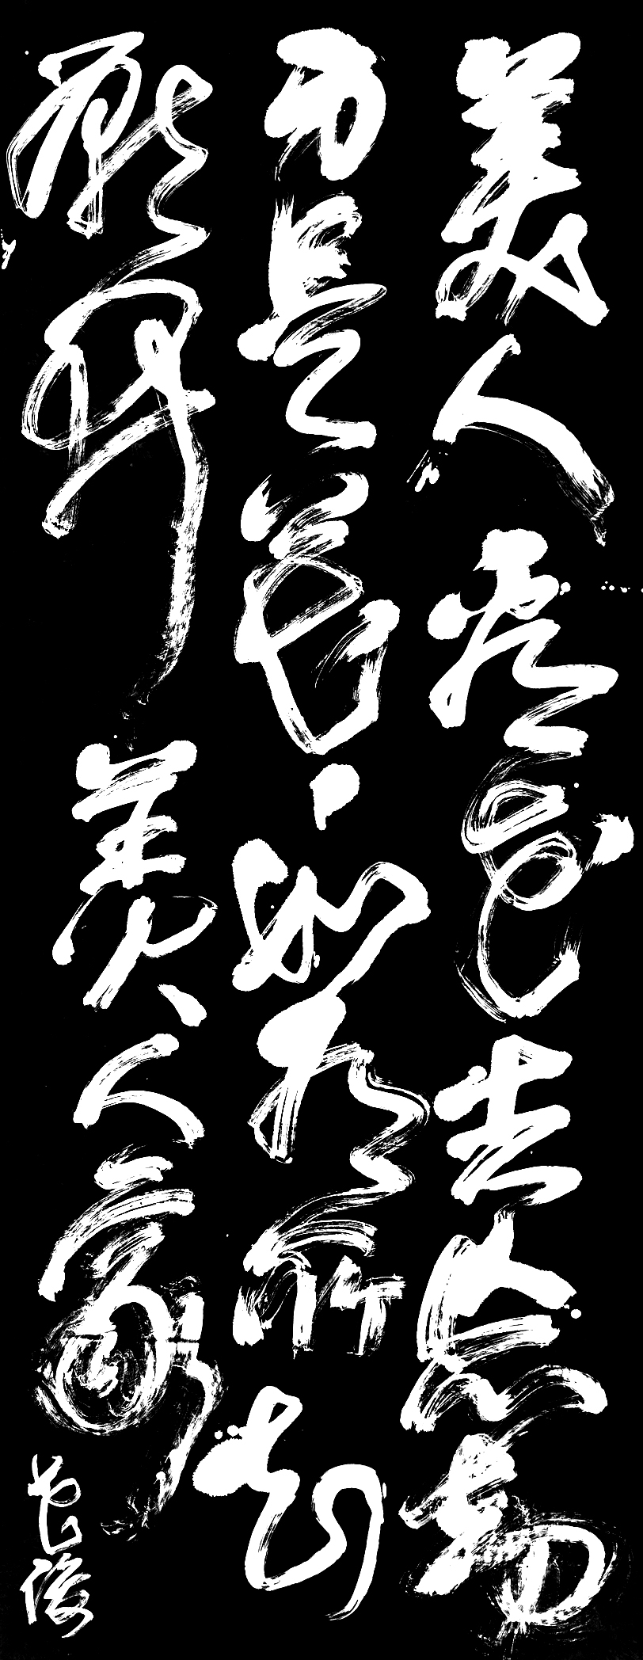

中国书法

晨和夜
围着毛笔旋转，变成字
和母亲的教诲：“一切都在这里。苦练
才能不朽！”
雨抽打一扇扇关闭的窗子
和窗背后的脸谱
我带着同样的墨上路
我写着同样的字！
天和空，为什么是同一个意思？
云笑而不答
撒下鹅毛大雪
墓地亮出着一块块巨墨
哦一切都在这里：名字，出生年月
我，一支轮回千年的笔，在写
大地展视死者写过的字
天空俯身察看
很快又铺上一张宣纸。继续苦练！

Chinese Calligraphy

Morning and evening
Swirl around an inkbrush, become characters
With mother’s instruction: “All is contained in this. Diligent practice
Is the route to enduring art!”
Rain lashes all the closed windows
And mistakes made behind them
I go journeying with the same kind of ink
Heaven and sky, why the same meaning?
Clouds laugh without giving answer
Sift down flakes as large as goose down
Putting giant inksticks on exhibit
All is contained in this
An inkbrush reincarnated for a thousand years—I keep writing
The land exhibits characters written by the dead
The sky gazes down upon them
In no time lays out a sheet of rice paper.
Continue this diligent practice!

上海，癌病房

雨声挤入
弯成你洗衣时的背
你睡着，梦见用不懂的语言
在雪中寻问我的住处
我握着你的手
如当年握住那本出国的护照
只有流亡者的情人——雨
才能解释为什么
八年中我们只见了两次
如果此刻我弯腰低语：“我，你的儿子
看见了两个世界”
你一定不会睁开眼睛
或露出我第一次叫喊“妈妈”时的微笑
对于你，世界只有一个：
空中的鸟
也是岸上喘息的鱼

你睡着，平静
像深池里的鱼。你从未更换过语言

Shanghai, Cancer Ward

Sound of rain crowds in
Becomes your bent back over a washtub
You lie there and dream of using unfamiliar words
To ask my dwelling place amid the snow
I hold your hand, as I once held
The passport that let me go abroad
Only the rain, this partner of exiles
Can explain why
You only saw me twice in nine years
If I were to say to you now:
“I have seen two worlds”
You would not widen your eyes
And show the smile you gave
When I cried “Mama” the first time
To you, the world is only one:
The bird in midair
Is also the fish gasping on the bank

You lie there asleep, serene
Like a fish in a pond. You did not change your language

听死者讲汉字

你先拿出的是“福”
福， 你说，就是有饭吃，有衣穿……
田野在我眼前闪现
弯腰的农民，草帽……
当然，每个时代每个人对福的理解
都不一样
福， 我认为，就是
不生病
受骗时道一声谢谢
挨耳光时听见自己发出爽朗的笑声

一个既像锯子又像含羞草的字
这个字，你说， 就是我们的
“我”
它的左边是人，右边是兵器
意思是
一个人只有武装自己，才能成为自我
佛能一叶渡海
成吉思汗能骑马射箭
毛泽东会吟诗打仗……
要是人没有武器呢？我问
那她是就是任人宰割的
牲口
记住，手艺，就像思想
也是一种武器，而且是最好的武器

这字我知道，是“物”
由牛和刀构成，我说
孩子，你看到的
仅只是表面。这个字
其实说的是：所有被用，被杀的
东西
都叫物
比如橡树，印第安人，猪等
要在物化的世界里
生存，就应该变成
刀，越锋利越好
也许你在想。但人
一旦变成刀
也就成了工具，物

你拿起报纸，点燃一根火柴
报纸上领袖的像
迅速变黄
发黑。我的手
刚伸出去想挽救图片
立刻又抽了回来——烫
这
就是灰烬的“灰”字
灰就是
火灭后，才能摸到的东西

四堵墙围着一个人
这是“囚”，你说
墙，可能是宫殿
也可能是茅屋
但有一种无形的牢笼
在你想飞的时候
围住你，用大海的颜色

两个人并肩在走
这是“从”，跟随，顺从的意思
为什么会是这个意思，我问
你从厨房
拿来两只汤碗
铛地一声，相撞的碗
碎成满地的瓷片
凡多于一人以上的地方， 你说
一定就有矛盾，暴力
要步调一致
你就得牺牲个性
所以孔子曰，君子不党

水 + 舌头
这是生活的“活”，你说
它简练，精确
像一首好诗。
水，可以是泥土，舌头
也可以是树
岸上翻滚的鱼
是“活”最好的注释

你手掌一翻，亮出
“死”
死，你说，就是黄昏
和匕首
同时被埋入柔韧的皮——地面
抚摸
和恐吓
都无法让它起鸡皮疙瘩

嘴在黑暗里张着
这是名人的“名”
名，就是向深渊
证实自己的身份
“我！这是我！”
但又有多少张脸被真正看清？

一只羊头
这是善良的“善”
从羊那里人看到了善
从善那里人学会了吃羊
从吃羊
人学会了吃的本领
于是人说：善，就是本领

一个框子框着一块玉
这是国的“国”
国
就是把宝贝圈起来
以前这字不是这样的
以前世界不是这样的
以前，国家是
斧头和城池
后来有人——一个野心勃勃的皇帝
把星星圈入了框里
这才像国家！他说
但星星很快挣脱了牢笼，回到了天上
后来国变成了被框住的
剑……
直到不久，剑
才被一块玉取代
玉说，国家就是把疆土
当作自己的
肉
所以现在的战争比任何时候都残忍！

Lecture on Chinese Characters, by the Dead

First you bring out the character 福
Fú, you say, is having food to eat, clothes to wear
A field comes into view
Farmers bent at the waist, straw hats
Of course each era counts its blessings
In a different way
Fú , as I see it, means
Not falling ill, and when you get tricked
Say thank you, and when you get slapped
Your body will reverberate with crisp laughter

A word like a saw, but also like a sensitive plant
This character, you say, is our
我 [wŏ]
The left side is a person, and the right is a spear
That is to say
A person must arm himself before he can be himself
The Buddha could cross the ocean on a leaf
Genghis Khan could shoot an arrow from horseback
Mao Zedong could recite poems while fighting a war
And what if a person doesn’t have a weapon, I asked
Then he is livestock
Ready for the slaughter
Remember that craft, just like thinking
Is a weapon, the best kind of weapon

This word I know, it is 物
It is made up of a cow and a knife, I said
Child, what you see
Is only the surface. What this word is saying
Is that anything which gets used or killed
Is a wù
For instance an oak tree, an Indian or a pig
In a thingified world
Survival should turn into
A knife. The sharper the better
You might think, but once a person
Becomes a knife he also becomes a tool, a thing

You pick up a newspaper and light a match
The leader’s picture in the paper
Quickly yellows
And looks charred. My hand reaches
To save the picture
But pulls back right away—too hot
This is the word 灰 that refers
To ashes and cinders
After destruction by fire is complete
Hūi is what you can touch

Four walls surrounding a person
This is囚, you say
The walls could be a palace
Or a thatched cottage
But there is also a confining space
That surrounds you
With the ocean’s color
When you want to fly

Two people walking shoulder to shoulder
This is从, meaning to follow along with
Why does it mean that, I ask in surprise
You go to the kitchen
Bring two bowls
A loud clink shatters them
To a floorful of shards
Wherever people number more than one,
You say, there is sure to be conflict
Violence
They need to be kept in step
So you sacrifice personality
Which is why Confucius said, the superior man does not
join factions

Water + a tongue
This is the活 that means living, you say
It is streamlined and precise
Like a well-written poem. Water
Could refer to mud, the tongue
Could be a tree
A fish flopping on the bank
Is the best annotation of huó

Your hand flips over, turns up
死
Sǐ, you say, is dwindling light
And a dagger buried at the same time
Within pliant skin--the good earth
No caresses or frightening looks
Can ever raise goose bumps again

A mouth gaping in the dark
This is名[míng]—the kind that famous people have
Fame is proof of your own identity
Turned toward the abyss
“I’m the one. Here I am. ”
But how many faces get seen in a clear light?

The head of a sheep
This is善[shàn], which is shown by good deeds
People saw goodness in sheep
From the sheep’s goodness, people learned
They could be eaten; from eating sheep
People became capable of eating well
So people say, it takes goodness to gain capability

Here is a frame, framing a piece of jade
This is 国[guó], which means nation.
You say it means that a nation
Puts treasures within its perimeter
In the past, this word was not written this way
In the past, the world was not set up this way
In the past, a nation was
A moat and an axehead
Later someone—an emperor of boundless ambition
Enclosed stars within his frame
Ours is a nation worthy of the name, he said
But soon the caged stars slipped back to heaven
Later the frame of the nation held
A sword
Which gave way in time to the jade
The jade says that a nation
Eats territory as its meat
So wars nowdays are crueler than ever

III

特朗斯特罗姆在故宫

高大的门槛挡住你坐着的轮椅
你站起身，弃下装备

空荡的龙椅和铜狮走来
他们向你要诗。他们想看到自己

宫殿深处，日晷旋转成轮椅
发出火车穿越夜的轰鸣

我们在终点站！墙。血色
人脸像无名的米粒在拥挤

但皇帝的旅程已经结束
他的笑响成了刀光闪烁的市场

Tranströmer at the Palace Museum

The high threshold obstructs your wheelchair
You rise to your feet, abandon your equipment

The empty dragon seat and bronze lions draw near
They beg poems of you—they wish to see themselves

Deep in the palace, the solar dial turns like a wheelchair
Makes the rumblings of a midnight train

We are at the last station! Red doors
Red walls. People’s faces are jostling like rice grains

But the journey of emperors is finished
Their laugh transforms to a market of glinting knives

孤 独

这些我叫不出名字的花朵
在亲切交谈，它们点头

我闻到芳香，它们的语言——香
在它们的根里

我触弄花瓣，我无法说出
它们的名字。我不能把根拔起

我查出它们的属性
我闻到更浓的香。它在我体外

但门外高大的银杏
让我跪下。它说着我童年的语言

Solitude

These flowers I cannot call by name
Are in a familiar conversation. They are nodding

I smell fragrance. Their language of scent
Goes down to the root

I run my fingers over the petals. I do not know
Their names. I cannot pull them up by the root

Having looked up their particulars
I smell a deeper aroma. It is outside my body

But the ginkgo outside my door
Brings me to my knees. It speaks my childhood language

水的生涯（俳句）
——致特朗斯特罗姆

1
船被拖上了岸
远离大海的笑声

2
暴雨倾泻。水中的脸
碎成一只只水泡

3
水泡。溺者的喊声
和活人生活在一起

4
看，深渊打开了星网
网孔是面孔

5
两只喜鹊在墓地里奔跳
这是去年春天

6
雪白的夜。冒烟的茶
屋子掌纹般陌生

7
孩子的哭声
星空被火车拖入了隧道

8
静。一节节熄灭的车厢
豪华的棺材

9
草湿透。风磨亮的月镰
正切割着梦

10
静轰鸣：好诗的语言
是事物自身的声音

11
烫热的吻。家
是什么？一阵痉挛的笑

Aqueous Life: 11 Haikus

1
A boat has been pulled onto the bank
Distant from the ocean’s laughter

2
Torrent of rain. Face in the water
Breaks into bubble after bubble

3
Bubbles-----shouts of the drowned
That live together with living people

4
Look, the abyss casts its starry net
Its openings are facial features

5
Two magpies hopping among gravestones
-----Recollection from last spring

6
Snowy night. Steaming tea
The rooms strangeness reminds me of a palmprint

7
A child’s crying sounds: Starry space
Pulled by a train into a tunnel

8
Stillness. Extinguished railroad car,
Luxurious coffin

9
Grass is drenched. Moon’s sickle sharpened by wind
Is cutting dreams

10
Silence thunders: Language of a good poem
Is the voice of what happens

11
A scorching kiss. What is a family
Anyway? Spasmodic laughter

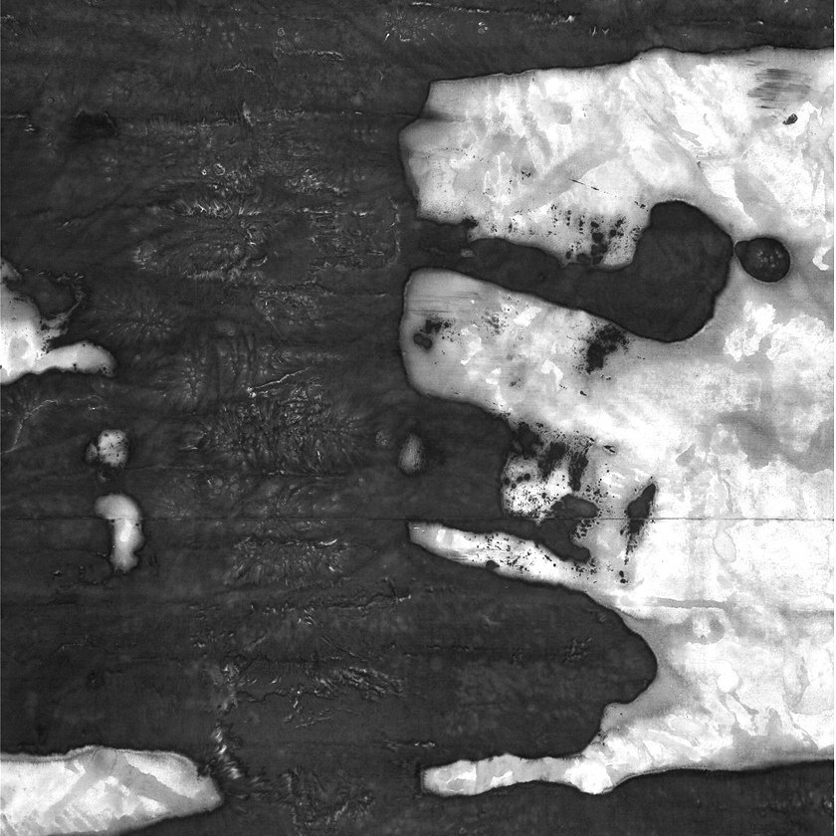

雪的自白

我向等待雪橇耕出同样伤口的大地坠落

我
摇晃，战栗
翻
滚
旋
转

我必须穿过空虚
才能够进入另一个世界

另一个世界是喧嚣的世界

“坠吧，坠落
你才能和大地融为一体”
朝天裂开的伤口对我喊道

我飘落
伤口含着我，像含着万能的白药

一堆垃圾
我飘向它
垃圾变成银金字塔

一道铁丝网
我飘向它
我变成死囚的泪水

一只张开的手
我飘向它
我化为一手冷汗

夜降临
黑暗把我酿成醉者的血液，闪光的音符
但没人注意我在消融

花园。一具曲线流动所有表演时装的
残缺的女尸！
我抱着它，想把它抱成一尊
古希腊雕像
奇怪，他抽缩起来（像油锅里的牛肉）
一个声音从我怀抱里争脱：你能改变美，但美
无法改变你生活

我飘落，前
就是后
我覆盖，黑
就是白

白天就这样到来
大街闪光
我突然变成一个被膜拜的
独裁者， 一张巨大的合同
脚印在那里纷纷签名
为了出卖，成功，为了活在此刻

一个一岁的孩子
被拉进了生活
他必须经历雪暴。哭
没用。脸红成西红柿
没用——“走，往前走，前面是滑车！”
摔成被雪埋掉一半的土豆
没用。他
必须站起，站成石碑
他站起，摔成手脚朝天的甲虫
没用——母亲的传统
压住了哭声

我飘落。事物在丧失自己
难以看清真相

池塘
一个映现天空的哑谜。我认出它。它是我
的镜子
奇怪，贴近的一瞬
我骤然消失，像扑火的飞娥

“你不用沮丧。你坠落，冬天
才变得完整！”
壁炉被点燃的木柴说

我落在一根枝条上
它弯曲，战栗
（象某个祈祷的形象）
我不知道枝条在回忆果实成熟的季节
还是在等风把我吹走

我留在那里
童话走来，穿过相机
变成一张明信片：一座威尼斯的水晶吊灯
它像烈日给南方冒汗的肉身投下阴影
生活在别处！

一
个女人
打开窗子
把我领入室内
她说：每次触及你
你就像梦中的蝴蝶消失
告说我，怎样才能捕获你灵魂
是不是应该用眼睛，而不是像现在这样

用手？

我没回答
我默默飘落

我飘落
我落在屋顶，落在墓地
落在荒野
落在伸出的舌苔上

脚印在互相噬咬，想争当不朽的诗句
我的激情——如瀑的坠落
变成相撞的汽车，流淌的呻吟

没人阻止我坠落，至少我自己
只有抵达地面
我的肖像才真正完成

哦，飘入沙漠的感觉是多么的奇特！
我听见我的脉搏
响成病房瓶里滴落的药水
沙漠没有泡沫的回音
它只有海绵汲水的器官
但我靠幻想坠沉：
把石灰白的我
看成走出深渊的五月的苍翠

一阵蛇在草丛爬行的声音——一张嘴
如《圣经》打开
词从深处升起，响成泉水：
“最初是词”

于是我变成了积雪
（坠落的知识化成一双双靴子！）
于是践踏向目标涌去
留下追问的痛苦：谁是我的脚印？

一封撕碎的信在我落地时恢复了原貌
黑字如伤痕闪现：

“北京也下起了雪
我想起斯德哥尔摩的雪天
我贴着一扇窗玻璃上的面孔
和疑问：我是谁？
我什么也不是
但却有着狼的孤独，兔子的惶恐……”信
写道

我看见他
和一辆送报的自行车
被异国的小路推入午夜

“这里发生了巨变……田里
长出了别墅……我也买了一辆奔驰”

他上坡，脚一滑，摔倒在地上
车上他看不懂的报纸
飞成巨大的雪片
他坐在雪地上恸哭
一颗童年的星星从东方闪现，向他俯身

“活，就是学会做狼
尽管你只是一只兔子”

他举着酒杯
搂着两个半裸的笑声
他放弃了陌生人护照。他返回了祖国

我飘落。祖国在这里：一条街巷的迷宫
表情的迷宫！
但我仍想去荒无人迹的荒岛
那里，我不会被践踏
那里铲子……

我为什么停在一棵圣诞树上？
因为我只好停在这里
海洛因的光泽（它被当成了福音）
喊出冬天和忍受的意义：
让火鸡的胸脯
露出大海八月的爱！

“我给她一只拳头大的雪球
我说这是凡·高的耳朵
她笑
我说这是尼采的耳朵，轮回的象征
她笑得更欢”

林中的雪坡变成美丽的滑梯
雪车欢叫着飞翔
根本就不存在锋利的石块
和坑

“其实雪和雪并没有差别
但树上的雪
我希望留下，留到四月
门口的雪
我看着看着便操起了铲子
屋顶的雪
是骨灰盒里的教训
腰疼时
我才发现：它们
正从日光灯的管子从书页从墙从床单从我
的血里渗出”

我
飘落
我飘落过。我还会飘落

我落在一个女人的脸上
她闭上眼。昵语飘荡：
“以前下雪，我就张开手掌
闪亮的星星融入我掌心
如今看见雪花
我就想打开龙头洗手。”

但另一个她—— 一个少女
把我从地上捧起
并小心塞入嘴中
她把我当成了棉花糖

我飘落
我落在一个孩子的脸上
孩子说：
“上帝的吐沫
把墓碑化成了雪糕，但没人愿意去舔！”

他冲我撒尿
真理向他显灵：一只睁眼的
洞

我落在一个老人的身上
老人说：
“以前我爱踩新雪
现在我只走别人踩过的雪”

我飘落。我躺在地上
感受被一台无形马达驱使的焦虑
踩着我向前涌去

一个问号——水泡——在我被踩成脏水时
浮起：你是谁？

没有回答

一个抱着牛奶的老人沿黄昏在走
他在回家的途中
他身子一晃，摔倒在地上
他在原地爬行
一只试图抓住深底的铁锚
成了晃动的浮萍

那是叫喊，重复的词
但没人倾听

连成镣铐的脚印在空荡的街上喘气
它们挣扎着想摆脱某种关系
它们像一张张无特征的脸
它们像脸组成的游行队伍
它们更像合同上
作废的
文字

它们在啜泣
直到我再次飘落
世界静成一个形同佛像的雪人

Snow’s Confession

I fall toward the earth that awaits a wound like one plowed by a sled

I go
tossing and trembling
rolling
over
and
whirling

I had to pass through empty air
to enter another world

that other world is a world of commotion
“just fall, take the plunge
if you wish to become one with the earth,”
that wound calls to me, open to the sky

I drift down
the wound mouths me, as if savoring a white cure-all powder
a pile of garbage
I drift toward it
the garbage becomes a pyramid

a fence of barbed wire
I drift toward it
and change into the tears of a prisoner

an open hand
I drift toward it
I transform into its clamminess

night falls
darkness brews me into drunkard’s blood and sparkling notes of
music
yet does not notice as I melt away

garden…set of curves teeming with grisly female corpses
that put on fashion shows
I embrace it. by the force of clasping arms I would have it
turn into a Greek statue
strange, it begins to shudder (like beef on the grill)
a voice slips from between my arms: you can change beauty, but beauty
cannot change your life

I drift down…forward
is no other than backward
I blanket things…white
is no other than black

in this way the daytime arrives
the street sparkles
suddenly I become the object of adulation
a dictator…and here is a gigantic contract
footprints make their signatures in profusion
to betray, to succeed, to live at this moment

a one-year-old child
is yanked into life
he must endure a blizzard. to weep
is no use. let his face turn tomato-red
no use---keep walking, the cable car is up ahead
tumble into snow like a half-buried potato
no use. he has to
stand up, with the stance of a stone plaque
he stands. falls with arms waggling like a beetle
no use---his mother’s tradition
suppresses weeping

I drift down. things are losing themselves
hard to make out their true outlines

a farm pond
enigma reflecting the sky. I recognize it. it is my mirror
strange, upon pressing close
I disappear in a flash, like a moth hurling at flame

“don’t be depressed. your fall is needed
to complete the winter!”
says the fireplace to the ignited firewood

I fall onto a twig
it bends and trembles
(like an image of one kind of prayer)
I cannot tell: is it recalling the season of ripe fruit
or waiting for wind to blow me away?

There I remain
A fairy tale draws near, passes through a camera
emerges as a snapshot: a crystal chandelier
like fierce sun on a sweaty body, casting its shadow
life is elsewhere!

a
woman
opens a window
leads me into her room
she says: whenever I touch you
you disappear like a butterfly in wind
tell me, how can I ever capture your spirit
should I use my eyes, instead of what I’m doing

using my hand?
I did not answer
I drift down silently

I drift down
I fall on a rooftop, fall in a graveyard
fall on a wasteland
fall on the coating of a tongue

footprints bite hunks from each other, vying to be timeless lines
of poetry
my passion—like a plunging waterfall
becomes a collision of vehicles, moans along the stream

no one hinders my plunge, least of all myself
only on reaching the ground
will my portrait truly be finished

ah, so odd to feel myself drifting into a desert!
I can hear my pulse
like an I.V. dripping in a sickroom
the desert has no echo of bubbles
it has only organs to sponge up water
using fantasy I go into free fall
convince myself this chalky pallor
is May foliage, striding out from the abyss

sound of a snake slithering in grass—a mouth
opens like the Bible
words well up from the depths, an artesian spring
“In the beginning was the Word!”

this is how I become a blanket of snow
(plunging knowledge transforms to pairs of boots!)
these trudging steps pressing towards the goal
leaving the painful question: who are my footprints?

a shredded letter restored to one piece as I hit the ground
black words catch the eye like scars

“it has been snowing in Beijing too
I can’t help thinking of snowy days in Stockholm
up against my features in the window of a country house
I ask: who am I
I am not anything
but here is loneliness like a wolf, fright like a rabbit…”
so it was written in the letter

I watch him
along with a newspaper delivery bike
push deep into a midnight lane, in this alien land

“huge changes have happened here---the fields
have grown into villas…even I bought a Benz”

he walks uphill, slips and falls to the ground
newspapers he could not read on the bus
whirl into huge flurries
he sits on the snowy ground and weeps
a childhood star in the east twinkles down on him

“living means learning to be a wolf
even if you are only a rabbit”

he raises his glass
his arm around a décolletage of giggles
he gives up his alien’s passport, he travels back to his
motherland

I drift down, here is the motherland, a maze of streets and alleys
a maze of facial expressions

my thoughts still roam to a barren deserted island
there I will not be trampled
and the shovel there…

why do I come to rest in a Christmas tree?
Because stopping here is all I can do
promising white aura of heroin (some take it for gospel)
shouts out justification for winters endured
lets a turkey’s breast show
the benevolent sea of August

“I gave her a fist-sized snowball
said this was Van Gogh’s ear
she laughed
I said it was Nietzche’s ear, a symbol of reincarnation
she laughed gleefully”

the slope in the woods becomes a beautiful chute
a snowmobile goes airborne with peals of delight
there are no such things as sharp stones
and ditches

“actually there is no difference between snow and snow”
but the snow on trees
I want to leave it there, let it stay until April
the snow in the doorway…
just the sight of it makes me reach for a shovel

snowflakes on the roof
are reminders from a crematory box
when my back aches
I discover they are emitted
from fluorescent bulbs and book paper and bed sheets
and my own blood

I
drift down
I have been falling, will keep falling

I land on a woman’s face
her eyes close. The lilt of her teasing voice:
“before when it snowed I would open my hand
feel them tingle and melt in my palm
now at the sight of snowflakes
I think of turning on the faucet”

but another one—a teenage girl
saved me from the ground in her cupped hand
and carefully put me in her mouth
she thought I was cotton candy

I come drifting down
I land on a child’s face
the child says
“the Lord spits
and gravestones turn to ice cream
but nobody wants to lick it!”

he urinates in my direction
truth is manifest to him: a single
staring cavity

I land on an old man’s body
the old man says
“in the past I loved to tread on new snow
now I only walk on snow that others walk on”

I come drifting down. I lie on the ground
feel the angst of an unseen motor closing in on me
trampling me and charging ahead

a question—a bubble—floats up as I get trampled
into dirty water: who am I?

no answer comes

a man holding milk to his chest walks by twilight
he is on his way home
his body lurches, pitches to the ground
he is crawling in one place
an anchor that tried to grab the deep bottom
now a leaf of duckweed rocking back and forth

those are shouted sounds, the word repeated
but no one is listening

footprints joined into manacles are panting in the empty street
they struggle to pull away from certain connections
they are like one featureless face after another
they resemble a procession of faces
no, they are more like words
written on a contract
then rubbed out

they sob mutedly

I come drifting down
till the world takes on the silence
of a snowman in the shape of a Buddha

给洗礼后的儿子

两种文化的血汇成你，西梦——你父亲
那代人的信念：月亮，是西方的圆

它像灯塔照耀，把青春的船
领入西寻故乡的风暴。我们触礁下沉

但你出现了，神奇的锚！我抱着你
像纸抱着黑字。你教会我聆听哭喊

你在飘泊——两种不同的语言
正在你哭声里碰撞成无边的波涛。你也是船！

For Simon, after His Baptism

Blood from two cultures
Mixed to make you: Simon—your father
Held this credo in his time: the moon in the West was brighter

It was a lighthouse, luring young ships into storms
On their westward search for a homeland
I have seen them broken on the rocks

But you appeared, miraculous anchor! I hug you
As paper embraces the written word
You taught me to listen for crying

Ah, you too are adrift. Two different languages collide
In the boundless surf of your crying
You are a ship too!

Contents（目录）

迁鸟（4）
Bird of Passage
雪（6）
Snow
交往（10）
Having a Relationship with a Chinese Man
旅行（16）
Traveling
在克雷特岛（18）
On Crete
在埃及（20）
In Egypt
纽约（30）
New York
瞬间的巴黎（32）
Paris in an Instant
Porto Banus（34）
Porto Banus
栖居地（36）
Hermitage
1989年1月的卡夫卡（40）
Kafka in January 1989
1997年元夜的李白（48）
Li Bai on New Year’s Night, 1997
诗艺（50）
Poetry As Craft

无泪的葬礼（52）
Burial without Tears
祖国（54）
Motherland
邂逅（56）
Chance Encounter
履历（58）
Resume
自画像（64）
Self-Portrait
中国书法（68）
Chinese Calligraphy
上海，癌病房（70）
Shanghai, Cancer Ward
听死者讲汉字（72）
Lecture on Chinese Characters, by the Dead
特朗斯特罗姆在故宫（84）
Tranströmer at the Palace Museum
孤独（86）
Solitude
水的生涯（俳句）（88）
Aqueous Life: 11 Haikus
雪的自白（96）
Snow’s Confession
给洗礼后的儿子（116）
For Simon, after His Baptism

Calligraphy：huajun
Design：ruanmeihui
630 Fifth Ave,
45 Rockefeller Plaza.
Suite 2062
NY 10111-2000
Prise：USD:8 HKD:28
ISBN 0－9707596－6－5

